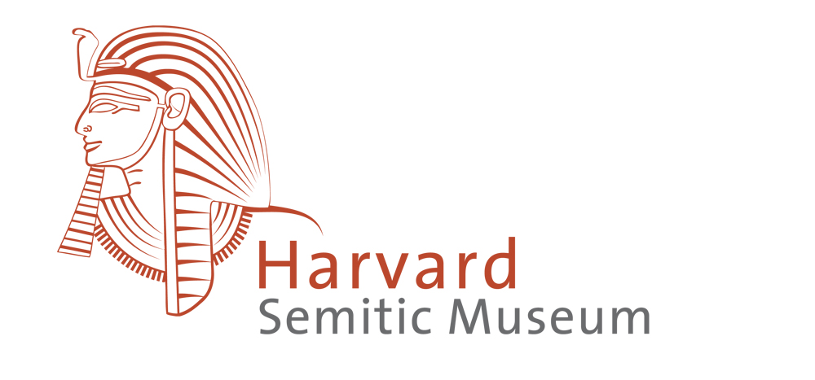

Volunteer Docent Application

The volunteer docents at the Harvard Semitic Museum are vital with helping to fulfill part of the Museum’s mission: to educate the public. These committed individuals provide a welcoming and informative environment for groups and other visitors by leading guided tours of the galleries.

Name:

Address:

Phone:

Email:

Why are you interested in being a docent with the Semitic Museum?

Please describe your interest in Ancient Near Eastern archaeology.

Please describe your educational background.

Please describe your work experience.

Have you worked with children in a group context? Please describe, including age ranges.

Have you worked with adults in a group context? Please describe.

Please describe any additional skills or training that you have that are relevant to this work.

Please submit your completed application via email to Adam Middleton at semiticm@fas.harvard.edu.

Thank you for your interest in the Harvard Semitic Museum!

